Multiple symptom
technique for detecting Parkinson's disease

VANI S BADIGER
Assistant Professor,ECE
Rajarajeshwari college of engineering
Bangalore, INDIA
vanisbadiger@gmail.com
HAMSA N R
Electronics and Communication
Rajarajeshwari college of engineering
Bangalore, INDIA
hamsaram147@gmail.com
GAGAN N Y
Electronics and Communication
Rajarajeshwari college of engineering
Bangalore, INDIA
yatheeshgagan456@gmail.com
GAURAV K M
Electronics and Communication
Rajarajeshwari college of engineering
Bangalore, INDIA
gauravkmshetty104@gmail.com

Abstract— Parkinson's disease is a progressive neurodegenerative disease which is attacking 1 percent of the elder population in this world. Until now, the only way to discover about Parkinson's disease was for individuals to go to clinics or hospitals, but symptoms of the disease are also shown in between such visits. As a result, the present system is ineffective in providing early warning and accurate medical diagnosis to those who are affected. Parkinson's disease manifests itself in a number of different ways, including motor and non-motor symptoms. Motor symptoms are perhaps the most essential signs to look for when detecting Parkinson's disease. This project uses a combination of sensors to detect Parkinson's disease in its early stages, including an accelerometer, gyroscope, sound sensor, and EMG sensor, all of which are used to detect different symptoms of the disorder.

Keywords— Brain disorder, Parkinson’s disease, Lewy body dementia, accurate medical diagnosis, motor symptoms, sound sensor, EMG sensor, accelerometer, Arduino uno, LCD module, etc.

Introduction
Parkinson's disease is a neurological condition. Tremors, stiffness, and trouble walking, balancing, and coordinating are all symptoms of Parkinson's disease. The disease's symptoms usually appear gradually and deteriorate with time. As the disease progresses, people with Parkinson's disease may have difficulty walking and communicating. They may have mental and behavioral changes as well as sleep problems, depression, memory difficulty, and tiredness. Both men and women are affected by Parkinson's disease. Men, on the other hand, are more impacted by the illness than women. Parkinson's disease is linked to ageing, which is a well-known risk factor. The majority of people who develop Parkinson's disease do so around the age of 60, while about 5-10% of persons with Parkinson's disease do so before the age of 50. When nerve cells in the basal ganglia, a part of the brain that controls movement, become damaged or die, Parkinson's disease develops. These nerve cells, normally produce dopamine, an important brain neurotransmitter. When neurons die or become damaged, they produce less dopamine, resulting in Parkinson's movement issues. Scientists are indeed unsure what causes dopamine-producing cells to die.
Dopamine is a neurotransmitter, or molecule, that sends signals from the brain to the rest of the body. It is created spontaneously in several parts of the brain and is necessary for tasks like motor skills, cognition, and reproduction. The neurotransmitter rises in preparation of an important event, plays a critical function in the body's reward and motivation system, and has an impact on memory. Dopamine is responsible for these critical tasks despite accounting for fewer than 1% of the brain's neurons. This neurotransmitter is important for brain function in the appropriate amounts, but when it is reduced below a certain level, it might have undesired consequences on the body. Dopamine insufficiency has been connected to the development of neurodegenerative diseases.
Symptoms of Parkinson's disease might start out minor and continue to progress. Individuals who are affected may suffer minor tremors or trouble getting out from under a couch, for instance. They might notice that they talk too quietly, or that their handwriting is slow and limited, or that it is little and constrained. The person's face is expressionless and pixilated, or an arm or leg is not moving regularly, as the caretaker notices. Parkinson's disease patients frequently acquire a parkinsonian stride, which involves a proclivity to tilt forward, small fast steps as though rushing forward, and diminished arm swinging. Individuals might even have trouble starting or maintaining movement.
Detecting and monitoring the motor symptoms has a significant impact in early detection of the disease and helps doctors perform early diagnosis. Trying to suggest Parkinson's disease from the relaying solely on a single symptom is unreliable, because the disease develops differently in each patient, and the requirement for active participation may interfere with data gathering protocol adherence.
In this project, by constructing a screening process based on how a people interact with a prototype during everyday life, we establish a first move toward a data-driven method for the early identification of PD in this study. We want to use a multi-symptom strategy to detect Parkinson's disease by analyzing data collected inactively from several sensors. The model is intended for automatic Parkinson's disease detection depending on various sensors and addressing a variety of PD motor symptoms that are collected invisibly through sensors. Sensors that capture body motions, such as accelerometers, gyroscopes, or electromagnetic motion trackers, are used to analyze motor symptoms of Parkinson's disease. Other types of sensors have also been employed, such as those that measure bioelectrical activity (electromyography).

Literature survey
In recent years have been developed several systems for measuring or detecting symptoms of Parkinson’s Disease.
In [1] the authors have used sound sensor to detect Parkinson’s Disease. For effective detection, the authors have employed various voice features. The patient's speech fluctuations were used to detect PD in this method. However, the limitation of this method is Interference from background noise which can alter the speech signal recorded by the sound sensor.
The approach [3] employs an Inertial Measurement Unit (IMU) sensor that functions as a comprehensive tremor sensor. The tiny and integrated gadget is a benefit of this sensor unit. It also aids in determining tremor's cross-axis sensitivity. The disadvantage of employing this sensor is that it is prone to drift, or error that increases over time. Drifts have a considerable impact on the accuracy of these sensors' output. As a result, these sensors should not be used for an extended period of time.
In [7] introduces a method which detects PD by measuring the intensity of tremor. This method makes use of an accelerometer sensor to measure motion and a processor to translate the signals into signals that can be seen on a computer. Since the symptoms of Parkinson's Disease differ from person to person, this method focuses solely on detecting tremors, which may or may not be present in all patients.
Similarly, [4] proposed a method for detecting Parkinson's disease by monitoring how fast a person moves. The device uses an accelerometer to measure frontal trunk accelerations and a gyroscope to measure angular velocity in the sagittal plane. However, while Parkinson's Disease has several symptoms, this method only addresses one of them.
The approach [6] employs a self-developed gait detection platform that comprises of a u-shaped electronic walkway with flexible force sensitive pressure sensors. It is made up of 14 pressure pads, each of which has 25,600 pressure sensors arranged in a grid to extract a number of temporal and spatial gait data. This method's drawback is that it relies on several pressure pads, which might be difficult to assemble them quickly. It is also expensive due to the large number of sensors involved.
The authors proposed Spiral drawing in [2], which is an activity that may be used to measure an individual's muscle movements. The spiral sketching experiment is a challenge that requires delicate, continuous motions. The patient's own hand movement skill is reflected in the recording data. It's possible, though, that motor symptoms like tremor and stiffness contribute to muscular fatigue. Physical and mental fatigue are common in people who are suffering from Parkinson's disease. As a result, this task is not recommended because it may seriously impact the patient's health.
In [10], the authors provide an assessment tool that is similar to the preceding activity. By asking users to click on targets on the screen, this evaluation tool gathers data on their mouse movements. However, because the pace of mouse movement differs from person to person, this strategy cannot be employed for everyone.

Problem statement and motivation

Problem statement
Parkinson's disease (PD) is a neurological illness. It primarily presents as motor symptoms in the initial stages. This emphasizes the need for an accessible tool that can monitor patients remotely, unobtrusively, and throughout their regular activities, suggesting them to consult a doctor if it detects motor symptoms that could be linked to the early onset of Parkinson's disease. The methods for assessing and diagnosing Parkinson's disease are currently extremely subjective, as they rely on a clinician's judgement following a series of tests. Following the assessment, a doctor will grade the severity of the person's symptoms, such as tremor, using a rating system such as the Unified Parkinson's Disease Rating Scale (UPDRS). Mental health, behavior and mood, daily living activities, and motor skills are all covered in the UPDRS. The motor segment would be used to check the qualities mentioned previously. A person with PD may be asked to perform tasks such as the finger tapping test, the Archimedes Spiral test, and the nose tapping test. Various interpretations of the Archimedes Spiral test have been established in recent years. One of them requires the person with Parkinson’s Disease to sketch a lines and write on a digitizer tablet using a pen.
This type of examination revealed a deficiency that could lead to PD handwriting deficits. This technique of evaluation could help determine a person's level of finger dexterity if they have Parkinson'sDisease.Based on the traditional Archimedes Spiral test, a similar assessment tool has
been developed. In order to apply this method, the user has to draw a spiral over a template in the
typical way. This technique required the patient to recreate a spiral over a template in the traditional manner. The drawing was subsequently scanned and analyzed using a semiautomated computer software. But when the spiral test is done against the PD patient, they eventually get dizzy and fall unconscious in some cases.

Hence, we built a prototype in this project that combines various sensors to detect early-stage symptoms of Parkinson's disease and alert the individual if he is infected by measuring their tremors, body posture, and also monitor their voice by the use of sensors.
The below figure depicts number of patients infected with Parkinson’s disease. It has predicted that Parkinson disease has so far affected around 4.5 million individuals worldwide and the number continues to grow.

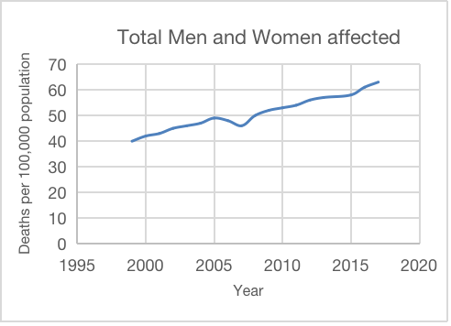
Fig1: Total men and women affected by PD

B. Motivation
The primary goal of these projects is to avoid human deaths by utilizing a multi-symptom approach to diagnose the disease in its early stages.

IV. proposed system and implementation

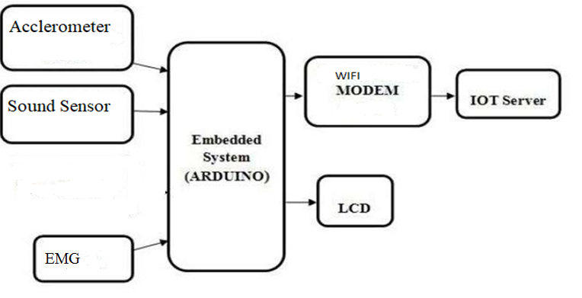

Fig2: Block diagram of proposed system

Proposed system
The use of wearable accelerometers, inertial, and electromyography sensors to automatically evaluate Parkinson's disease symptoms has been proposed as a way to cross the barrier of earlier methods. The device is designed to detect Parkinson's disease which has multiple symptoms, in which various sensors are used to collect data for all the symptoms. Wearable sensors can help clinicians with early detection, to detect new symptoms, and clear assessment of symptoms over time. To lessen the burden on caregivers. The wearable device can detect can in co-ordination of the body alignment and detect fall of patients and send an alert message to the caretaker’s smartphone if a critical situation occurs. A system like this is used in case of remote assistance.

Hardware components

- 16x2 LCD display
- Arduino Uno R3
- Accelerometer
- Sound sensor
- Power supply
- EMG Sensor
- Wi-Fi module

Methodology
First the person is made to do some simple exercises. These exercises include body movement exercises, speaking exercise, writing, running and walking. The tri-axial accelerometer is used to measure tremors and the data is sent to the microcontroller. Tremors are involuntary moment of body parts, and it is one of the commonly detected symptoms in PD’s patient. Sound sensor is used to record and differentiate Parkinson’s disease (PD) speakers and measure for the treatment are taken considering the speech recorded and collected in non-controlled noise situations. Accelerometer sensors are integrated in the device to obtain the final result of fall detection in much more accurate case. When you move your muscles, the EMG Sensor measures little electrical signals that are created by them. Lifting your arm or squeezing your fist are examples of this.
All the data collected from these sensors are sent to the microcontroller to determine if the person is suffering from Parkinson’s disease or not. The sensor values are monitored by the microcontroller. If the sensor values exceed the threshold values, then the details are forwarded to the concerned doctors and caretakers. The device is implemented using IoT technology in patient monitoring and used to store the sensor values and for easy cloud access by caregiver for further treatment.

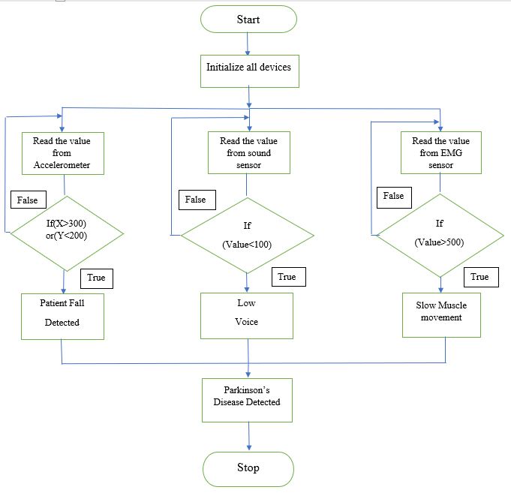

Fig 3: Flow chart

The above fig shows the flow chart in which the device works and communicates. Firstly, all the devices are initiated in the loop; the loop leads to three different functions where the process of the sensors used are done. Then in the first function, the accelerometer reads the values and compares it to the threshold value given, if the condition is true PD is detected and the message appears on the LCD display as well as the caretaker’s device. Similarly, the sound sensor and the EMG sensor used in the prototype reads the values and compares it to its respective threshold values to determine the condition is true or not. If the condition appears to be true, it displays the respective messages on both LCD and the caretaker’s device. Then the process stops. If at all the condition is false, the function returns and the person’s health is alright and isn’t diagnosed with PD.

experimental result
All the sensors mentioned above were implemented and the sensors worked as expected. Three people were chosen to test the developed prototype to ensure that it worked properly. When tested on healthy patients, the prototype demonstrated promising results. Although we were unable to test the prototype on Parkinson's disease patients, a random individual was chosen to replicate the behavior of a PD patient, and the device was tested on that person, yielding a positive result.

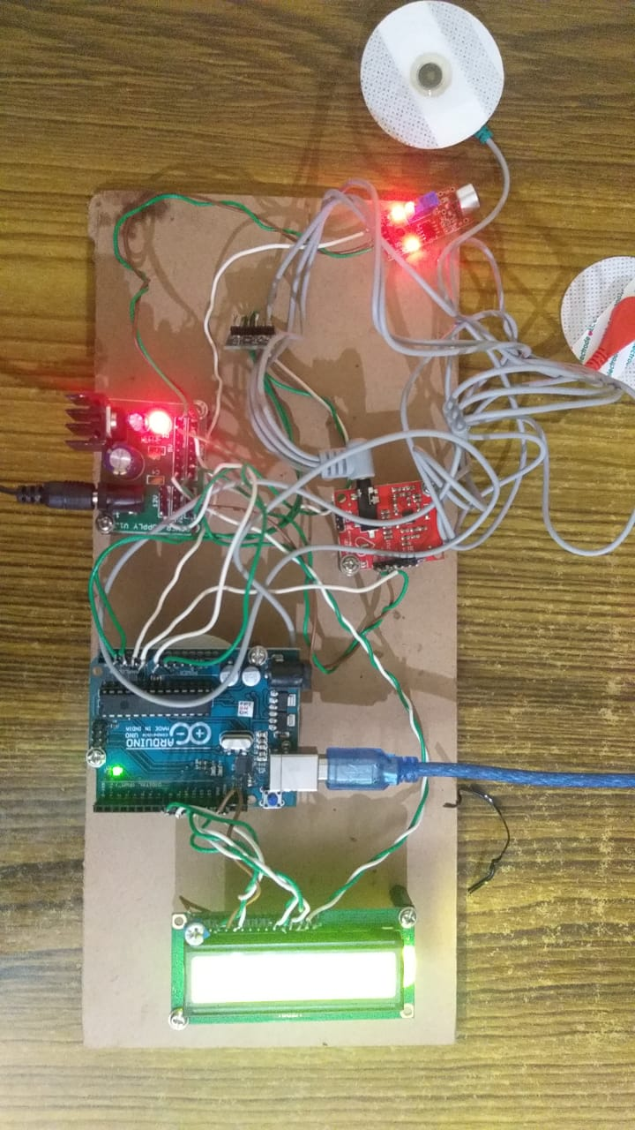

Fig 4: Experiment results

Conclusion
This paper describes a method for collecting and analysing symptoms from Parkinson's disease (PD) patients. This device is integrated with accelerometer, sound sensor, EMG sensor and Arduino nano to obtain the tremor signal, speech discontinuity and muscle movement. The Arduino is connected to the power supply. The accelerometer and Arduino nano are attached on the glove to collect the signal from fingertip, wrist, thigh and forearm. The sound sensor was placed near the mouth of the patient to record their voice. The EMG Sensor was used to measure the small electrical signals produced by our muscles as we move them, such as raising our arm or clenching our fist. This device is built in order to make it portable and comfortable to wear for the Parkinson’s Disease suffering patient and to analyse the results from the device and to guide the respected patient with proper suitable treatment.

VII. Future scope
The size of the microcontroller can be lowered to make this device more compatible to use. Using Arduino Pro Mini instead of Arduino nano could be one way to achieve this. The glove can be made in such a way that the sensors and Arduino are implemented on a single chip, in order to make it more compatible and reduce problem with the damage of sensors. Second, to avoid using a breadboard, the wires of the sensors should be soldered carefully and secured within the gloves to prevent accidents and fluctuations. Furthermore, Bluetooth and powerful Wi-Fi modules can be used in place of USB cables. The prototype can be tested on Parkinson’s disease patients to verify whether it produce accurate results. Second, to avoid using a breadboard, the sensor wires should be soldered carefully and securely within the gloves to minimize accidents and fluctuations.

Acknowledgment
We give our deepest thanks to our mentor, Raja Rajeshwari college of engineering for her unfailing support, guidance, and encouragement.

References

- Kemal Polat, “A Hybrid Approach to Parkinson Disease Classification using speech signal.” , IEEE, 2017.
- Min Wang1 , Bei Wang , Junzhong Zou , Jian Zhang , Masatoshi Nakamura. “ Hand Movement Compensation for Patients with Parkinson’s Disease Based on Polar Coordination System with Varied Origin”, IEEE, 2018.
- Vinayak Majhi, Sudip Paul, Goutam Saha, Jitendra Kumar Verma, “Sensor based Detection of Parkinson’s Disease Motor Symptoms.” , IEEE, 2014.
- Arash Salarian, Member, Heike Russmann, François J. G. Vingerhoets, Pierre R. Burkhard, and Kamiar Aminian. “Ambulatory Monitoring of Physical Activities in Patients With Parkinson’s Disease.”, International Journal of Computer Science and Engineering Communications, vol. 2, 2014, pp. 93–96
- Kostikis, et al. “Towards remote evaluation of movement disorders via smartphones,” in Proc. 33th Annual International Conference of the IEEE EMBS, Boston-USA, August 2011, pp. 5240 – 5243
- Xi Wu1 , Xu Chen , You Duan , Shengqiang Xu , Nan Cheng , Ning An, “A Study on Gait-based Parkinson’s Disease Detection Using a Force Sensitive Platform ”, 2015.
- Niya Romy Markose, Priscilla Dinkar Moyya , Mythili Asaithambi. “Analysis of Tremors in Parkinson’s Disease Using Accelerometer.”, Biomedical Engineering Conference NEBEC, 41st Annual Northeast. IEEE, NY, USA, April 2015, pp. 1-2
- A. Bermeo, Student Member, IEEE, M. Bravo, Student Member, IEEE, M. Huerta, Senior Member, IEEE and A. Soto, Member, IEEE, “A System to Monitor Tremors in Patients with Parkinson's Disease .”, Latin American Congress on Biomedical Engineering CLAIB 2014, Buenos Aires, Argentina 29, October 2014, pp. 785-788.
- R. Lemoyne, T. Mastroianni, M. Cozza, C. Coroian, and W. Grundfest, “Implementation of an iPhone for characterizing Parkinson’s disease tremor through a wireless accelerometer application,” Annu. Int. Conf. IEEE Eng. Med. Biol. Soc. IEEE Eng. Med. Biol. Soc. Annu. Int. Conf., vol. 2010, pp. 4954–4958, 2010, doi: 10.1109/iembs.2010.5627240
- L. Cunningham, C. Nugent, G. Moore, D. Finlay, and D. Craig. “Identifying Fine Movement Difficulties in Parkinson's Disease Using a Computer Assessment Tool.”, IEEE, 2020.
- H. Zhang, X. Chen, W.-Y. Lin, W.-C. Chou, and M.-Y. Lee, “A novel accelerometer-based method for the real-time assessment of Parkinson’s tremor,” in 2014 IEEE International Conference on Communiction Problem-solving, 2014, pp. 87–90, doi: 10.1109/ICCPS.2014.7062224.
- A. Zhang et al., “Automated Tremor Detection in Parkinson’s Disease Using Accelerometer Signals,” in 2018 IEEE/ACM International Conference on Connected Health: Applications, Systems and Engineering Technologies (CHASE), 2018, pp. 13–14, doi: 10.1145/3278576.3278582.
- S. Zabberoni, G. Carlesimo, A. Peppe, C. Caltagirone, and A. Costa, “Does dopamine depletion trigger a spreader lexical-semantic activation in parkinson’s disease? evidence from a study based on word fluency tasks,” Parkinson’s Disease, vol. 2017, 2017.
- B. Gupta and A. Bala, "Parkinson's disease in India: An analysis of publications output during 2002-2011," International Journal of Nutrition, Pharmacology, Neurological Diseases, vol. 3, pp. 254-262, 2013.
- J. Jankovic, "Parkinson’s disease: clinical features and diagnosis," Journal of Neurology, Neurosurgery &amp; Psychiatry, vol. 79, p. 368, 2008. M. Nyemi, “Vehicle safe drive system. kakamega,” 2012.
- J. McNames, P. M. R. Aboy, and A. Greenberg, "Method and apparatus for continuous measurement of motor symptoms in parkinson's disease and essential tremor with wearable sensors," United States Patent, 2009.
- R. LeMoyne, C. Coroian, and T. Mastroianni, “Quantification of parkinson’s disease characteristics using wireless accelerometers,” in Proc. Complex Medical Engineering, 2009. CME. ICME International Conference on, Los Angeles, USA, April 2009, pp. 1–5.
- R. Torres, M. Huerta, R. Clotet, et al. “A Kinect Based Approach to Assist in the Diagnosis and Quantification of Parkinson’s Disease,” in Proc. VI Latin American Congress on Biomedical Engineering CLAIB 2014, Paraná, Argentina 29-31 October 2014, pp. 461-464.
- Parkinson's Disease Society, Parkinson's Disease (PD) Atlas, Healthy Alliance, (2007).
- N. Dounskaia, A. W. A. Van Gemmert, B. C. Leis and G. E. Stelmach, Biased wrist and finger coordination in Parkinsonian patients during performance of graphical tasks, Neuropsychologia, vol 47, iss 12, pp 2504-2514, 2009..

